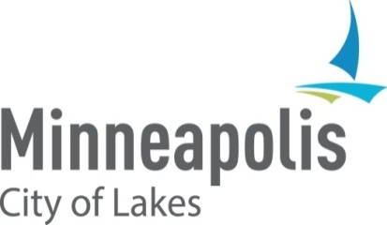

**2024 HUD Consolidated Annual Performance and Evaluation Report (CAPER) NOTICE OF PUBLIC HEARING**

## **When:** Tuesday, August 12, 2025, at 1:30 p.m. before the Business, Housing and Zoning (BHZ) Committee.

**Purpose:** To receive comment on the City’s Draft 2024 CAPER for CDBG, HOME, ESG, and HOPWA federal entitlement funding.

You are invited to comment on Minneapolis’ draft FY 2024 CAPER. The CAPER documents the City’s performance in its use of program year 2024 Community Development Block Grant (CDBG), HOME Investment Partnerships Program (HOME), Emergency Solutions Grants Program (ESG) and the Housing Opportunities for Persons with AIDS (HOPWA) federal entitlement funding. The draft Report can be viewed at <https://tinyurl.com/58va9jd8>

Written comments can be submitted to [matthew.bower@minneapolismn.gov](mailto:matthew.bower@minneapolismn.gov) from August 11, 2025, through August 25, 2025. Comments can also be provided at the public hearing. The City will be submitting the CAPER to the U.S. Department of Housing and Urban Development on August 29, 2025.

Information on how to participate in the public hearing can be accessed at the following website: <https://www.minneapolismn.gov/government/meetings/participate-in-a-meeting/> or by calling at 311 or 612-673-3000

For reasonable accommodations or alternative formats please contact Finance and Property Services at 612-673-3000 or via email at [finance@minneapolismn.gov](mailto:finance@minneapolismn.gov) . The City can provide CAPER materials in alternative formats. People who are deaf or hard of hearing can use a relay service to call 311 at 612-673-3000. TTY users call 612-673-2157 or 612-673-2626.

Para asistencia 612-673-2700

Rau kev pab 612-673-2800

Hadii aad Caawimaad u baahantahay 612-673-3500