

Office of
City Auditor

Mission
We strengthen public trust in City government by delivering independent, objective, and risk-informed oversight, assurance, and advisory services.

We safeguard public resources by identifying risks, promoting accountability, ensuring compliance, and supporting effective and transparent City operations.

Values
- Integrity
- Objectivity
- Fairness
- Competency

See Also
Minneapolis City Charter §4.2 (g)
MCO §8.130

Contact
CityAuditor@minneapolismn.gov

minneapolismn.gov/government/departments/auditor

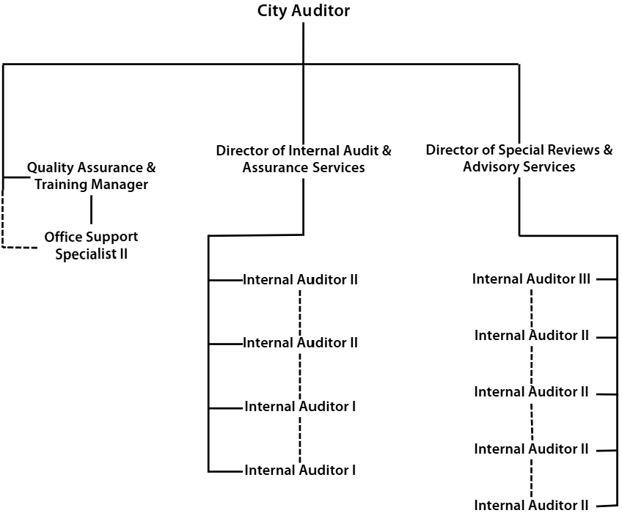

Organizational Chart
January 2026

