



City of Minneapolis eSupplier Bidding Guide

December 2018

# eSupplier Contracting Opportunities Overview

When navigating to the City of Minneapolis’ eSupplier portal, public events for solicitation posted by the City can be found on the Contracting Opportunities icon. Here, you can also view public announcements, upcoming events, and register or sign into the eSupplier portal. For assistance with logging in or bidder registration, see the eSupplier Bidder Registration and eSupplier Login guides found on the [City’s procurement website](http://www.ci.minneapolis.mn.us/finance/procurement/eSupplier).

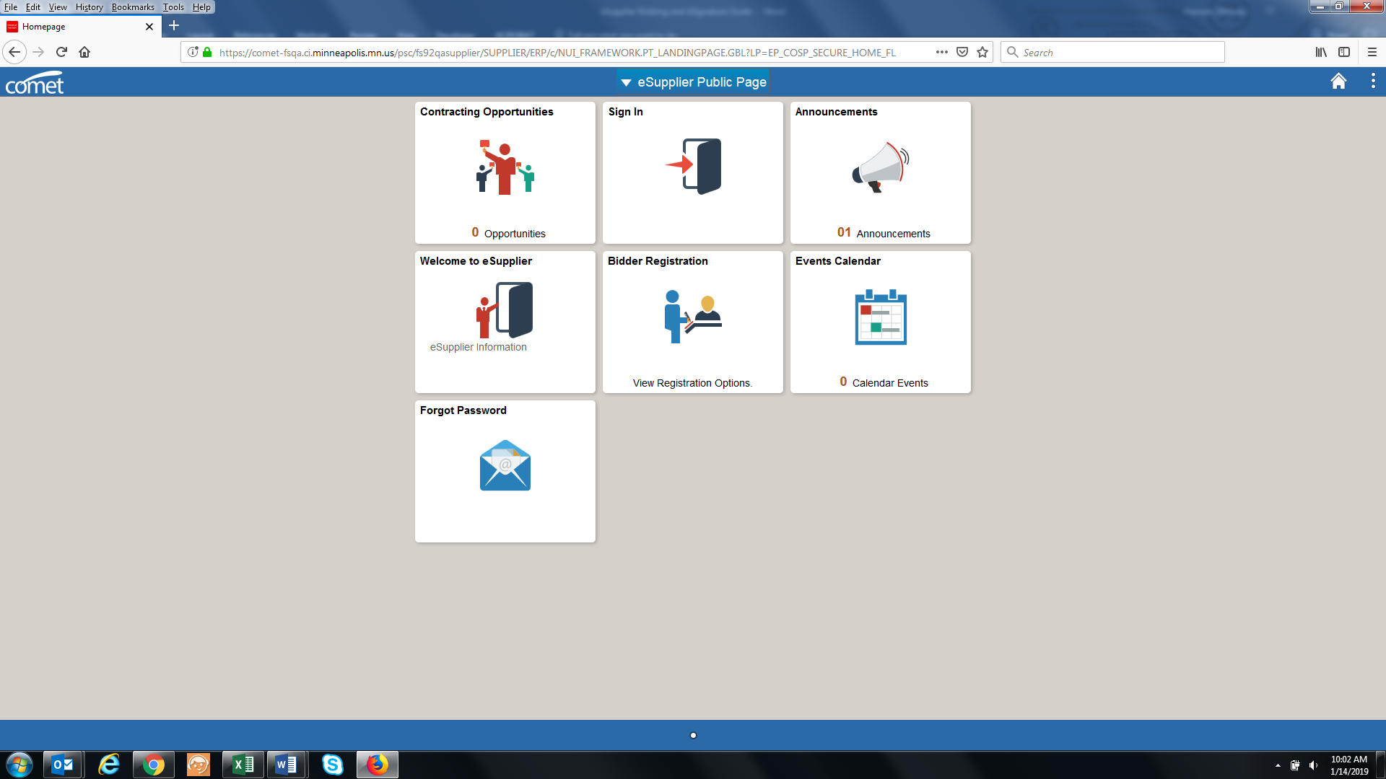

To review a public solicitation, click on the Contracting Opportunities tile located on the eSupplier Public Homepage. From here, you can view the public event information, when the opportunity ends, and the date range the need for solicitation.

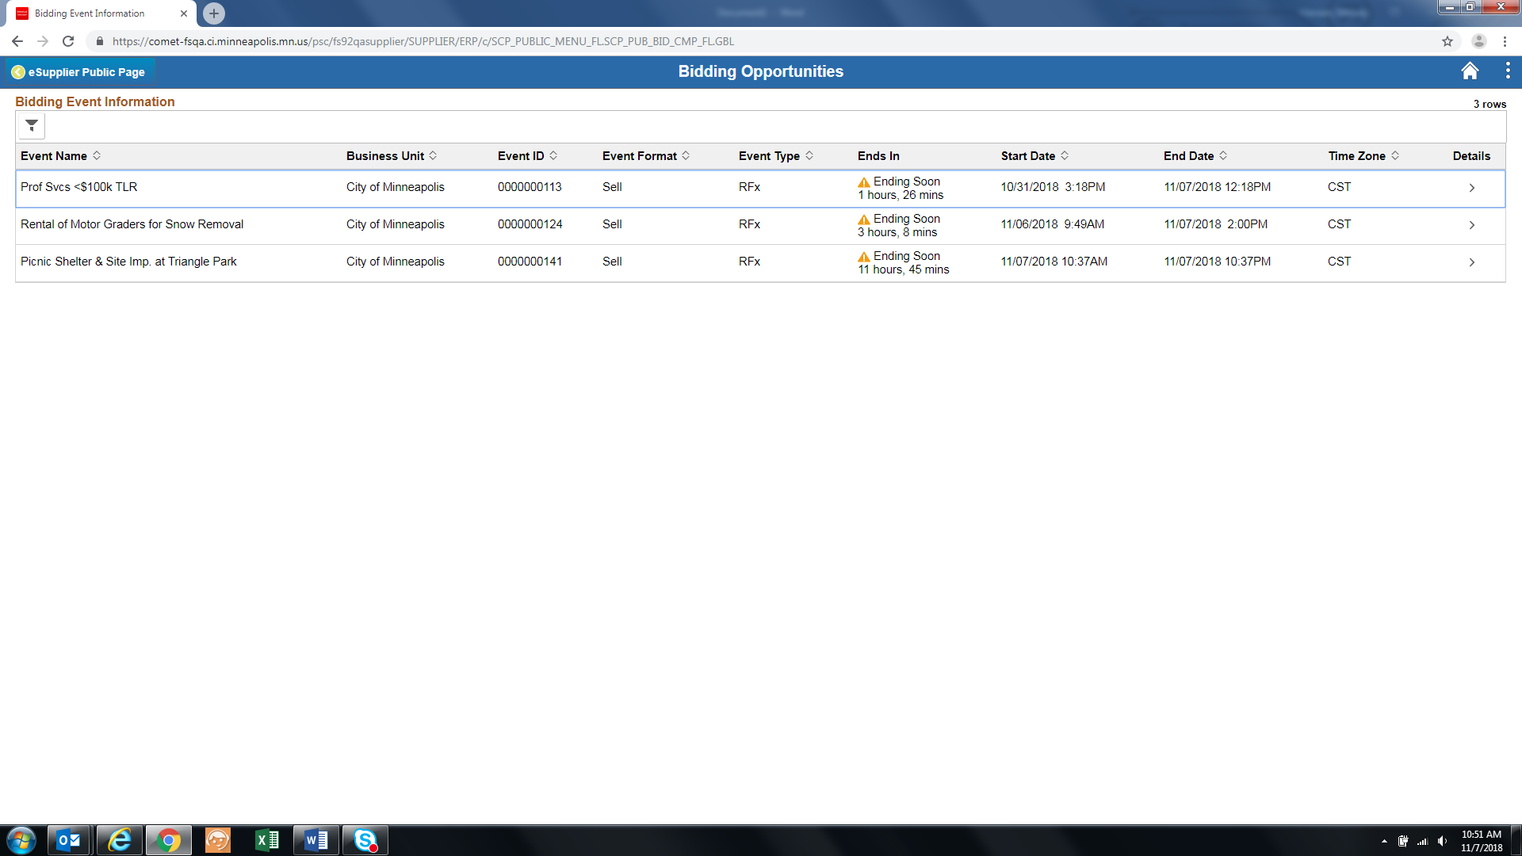

You may click into the event line at any point to review further bid opportunity details

# 

# Bidding on an Event

If the City has invited your organization to bid on a solicitation, an email will be sent inviting you to the event.

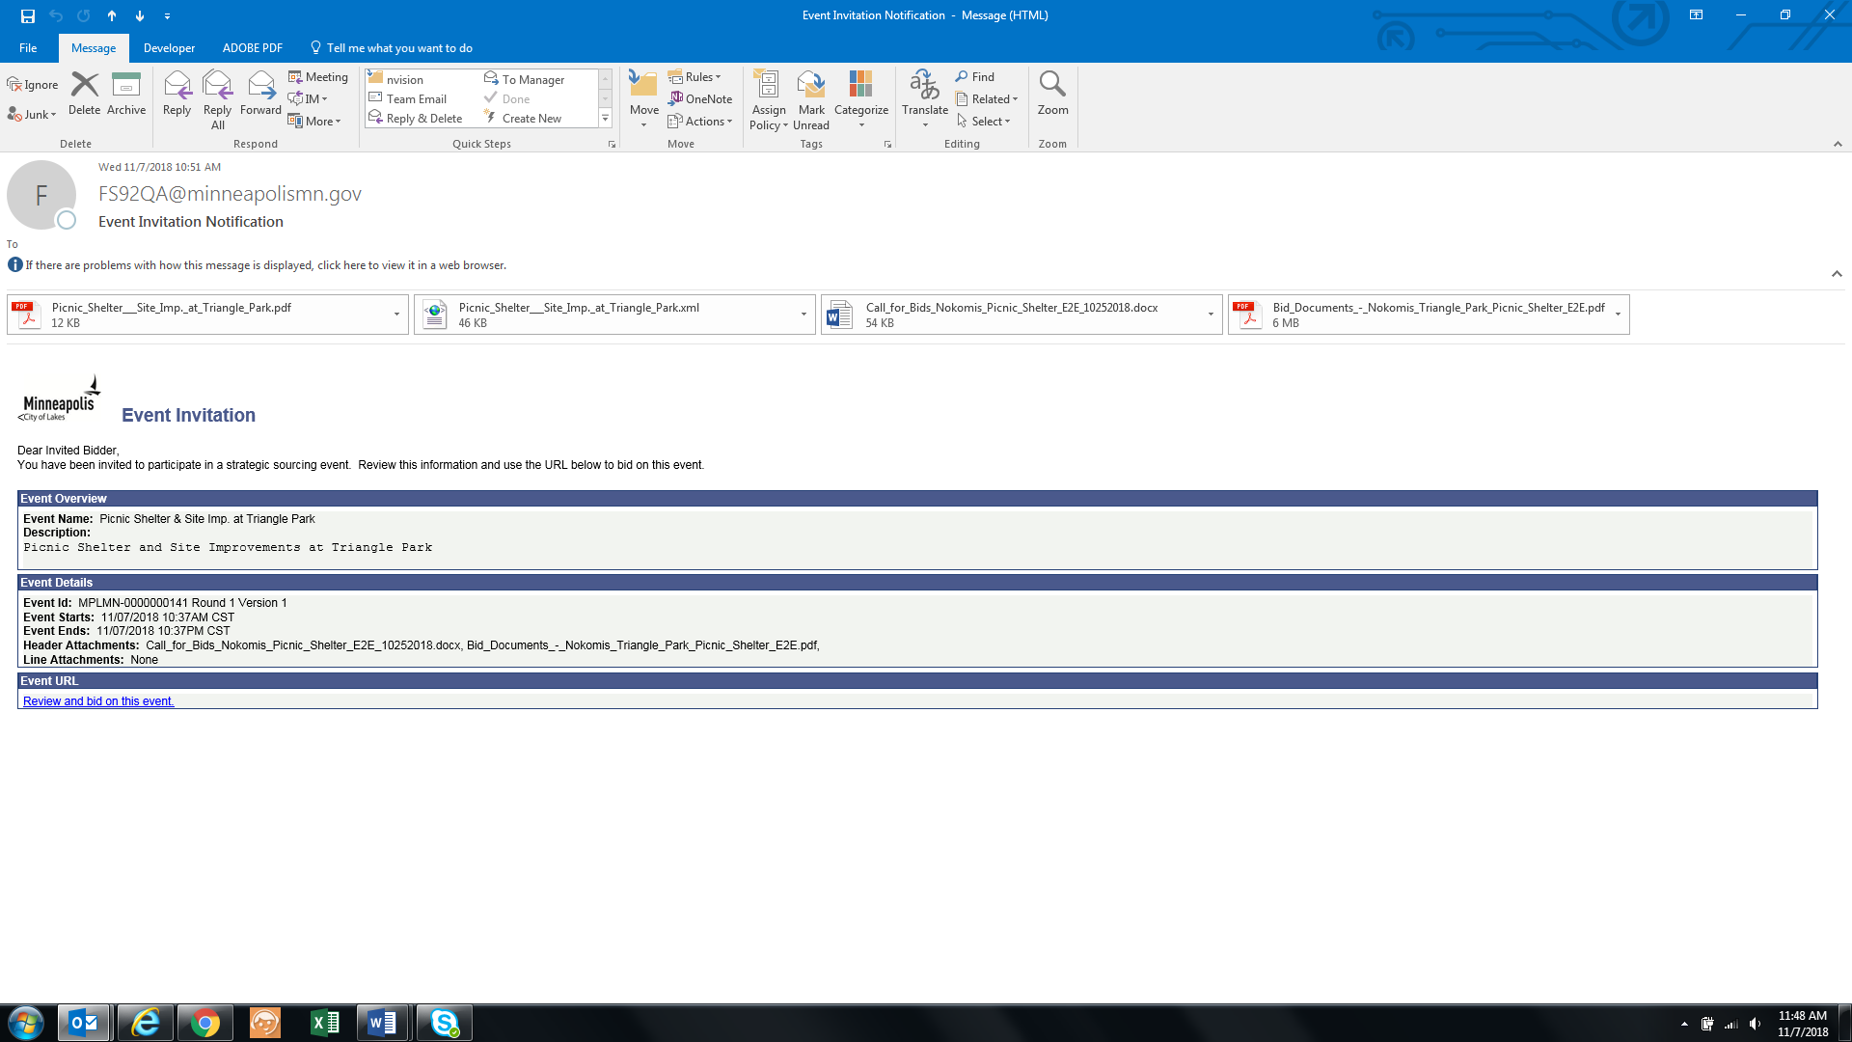

To bid on the event, you must login to the eSupplier portal. Registering and logging in assistance can be found in the eSupplier Bidder Registration and eSupplier Login guides found on the [City’s procurement website.](http://www.ci.minneapolis.mn.us/finance/procurement/eSupplier) Once you are signed in, you will be brought to a Secure Supplier Homepage. The “Contracting Opportunities” icon will look the same as it did on the public eSupplier page, however you can now bid on any available events.

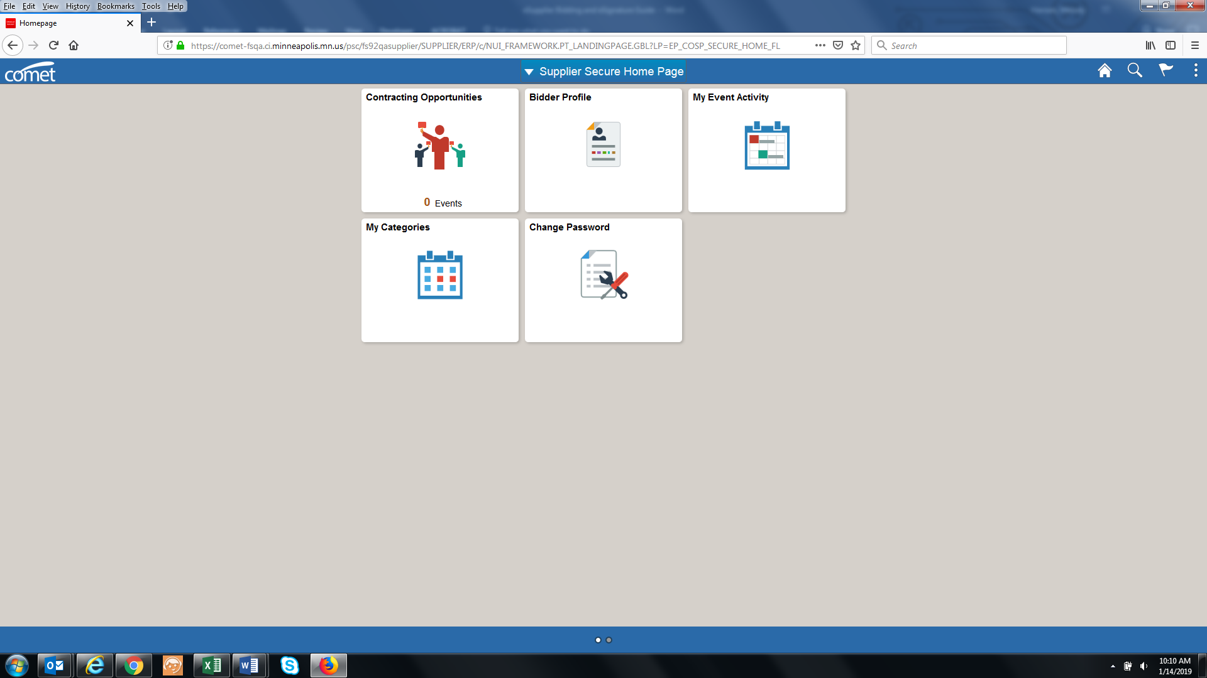

After clicking on the “Contracting Opportunities” icon, you will be brought to the event details page. If you have been invited to bid on an event, you will find the event on the Invited Events tab. All other public events can be found on the Public Events tab:

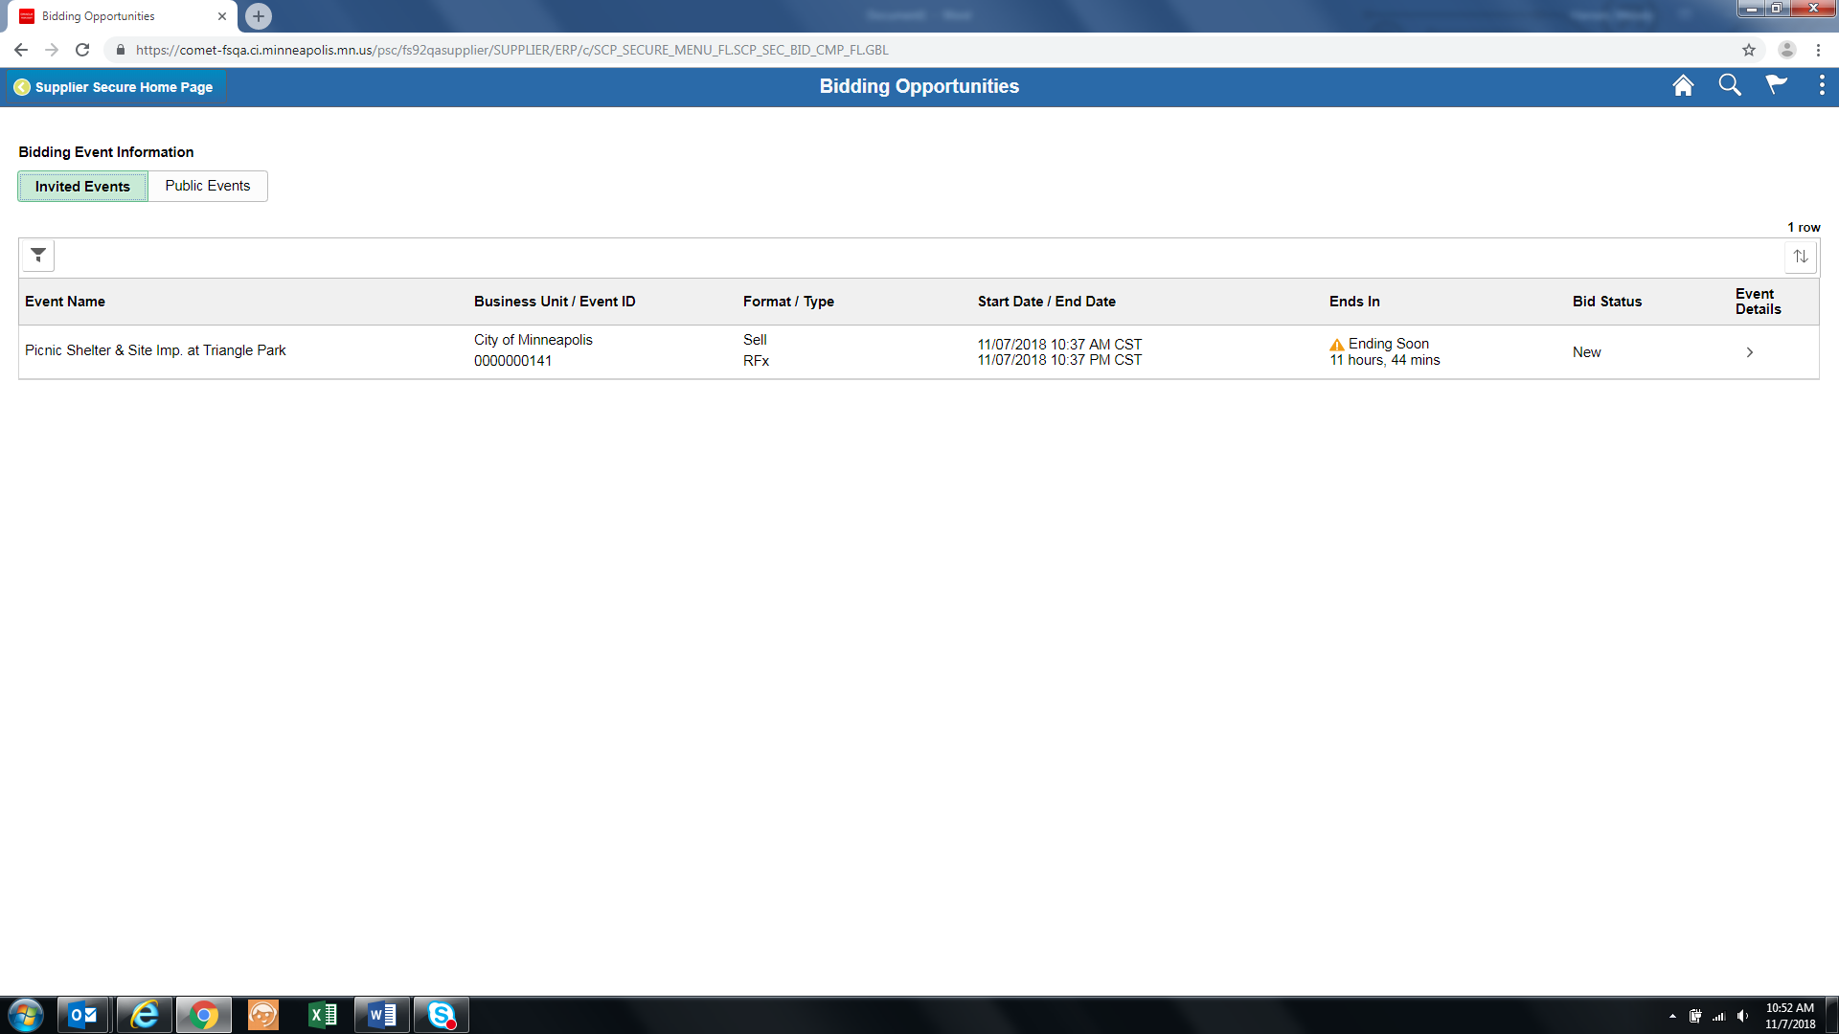

On the event details page, you can accept your invitation, view the event specifics, and place your bid. Below are steps you can follow to ensure you successfully bid on the event:

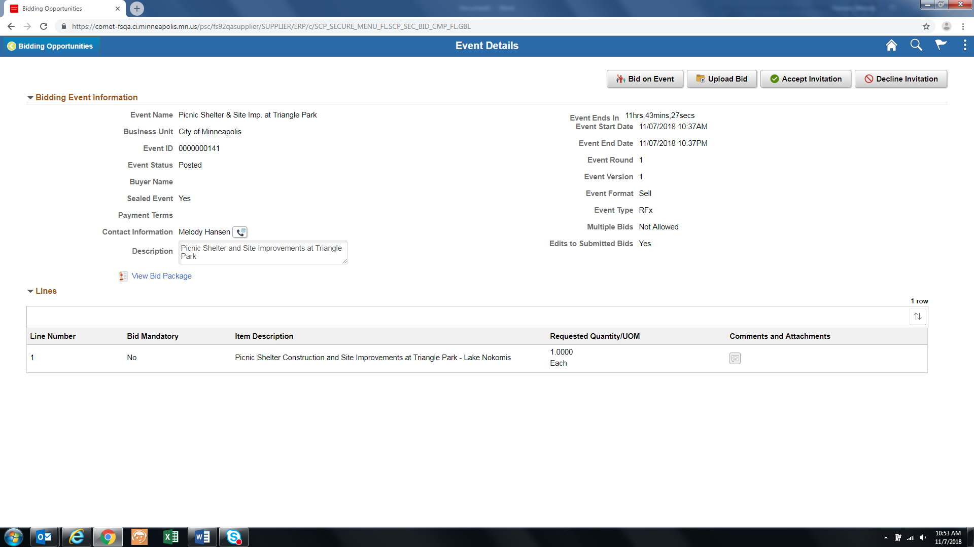

1. Click into the Bid Package hyperlink to view any related documents specific to the event. If you have been invited to the event and the event is public, you may see duplicated documents. One is specific to your Organization and the other is public. You can review and use either document:

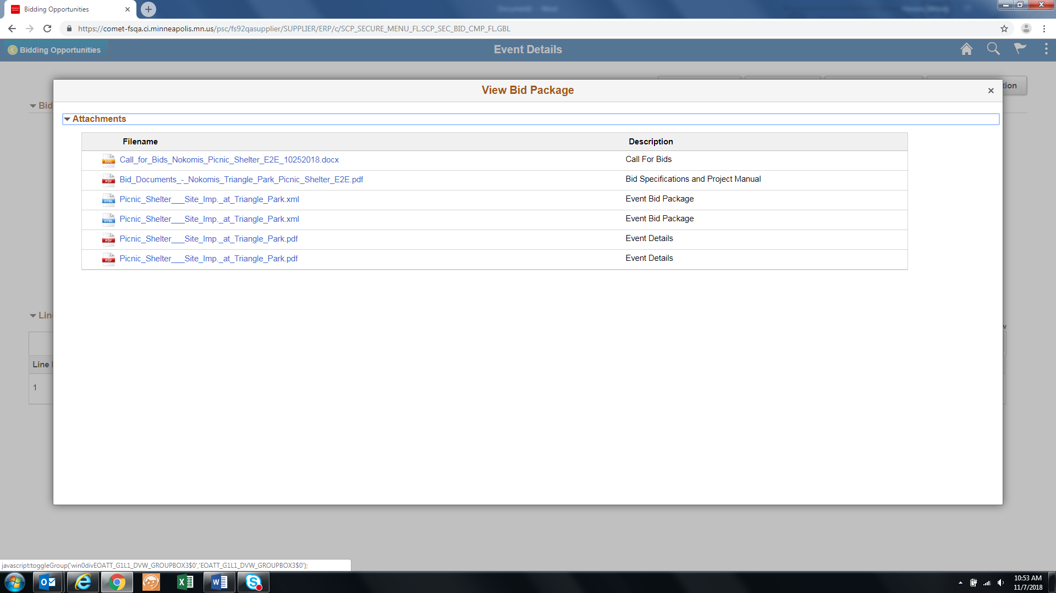

1. Click the “Bid on Event” button to start your bid process. You can also upload a bid via XML, by clicking the “Upload Bid” button. Through either of these options, you will be asked a series of questions that may require you to provide additional details and/or upload documents:

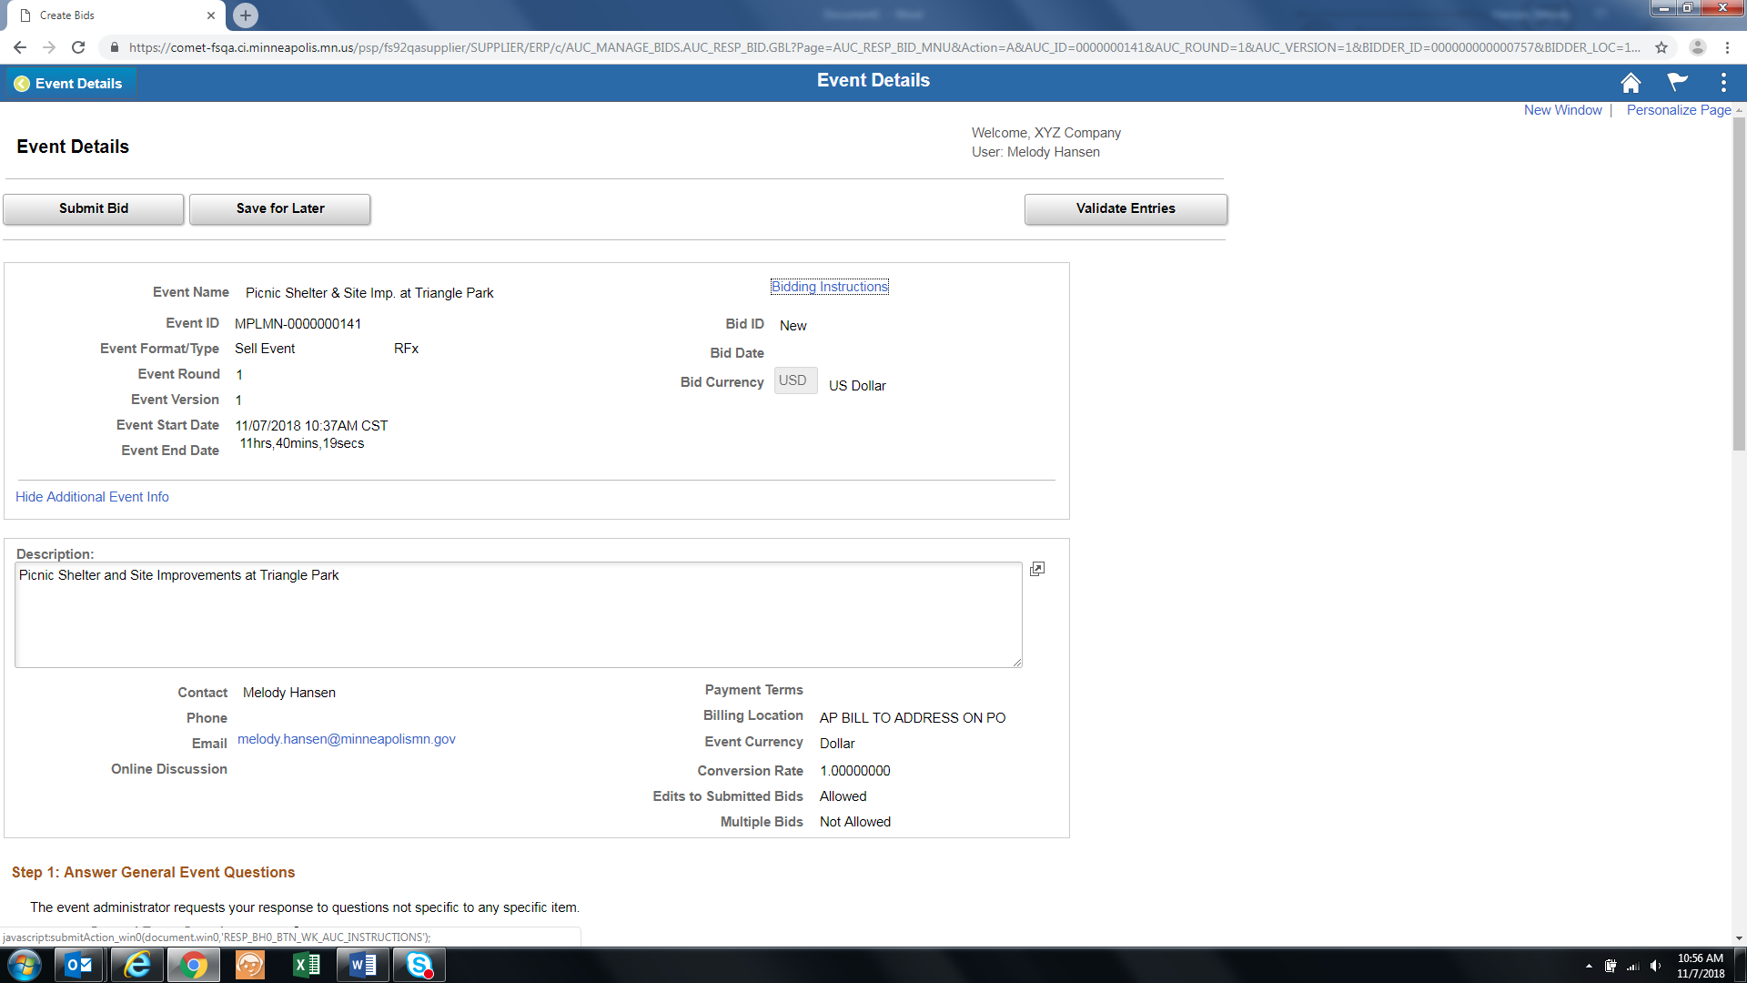

Required answers will be indicated as such through a **\*** character. To attach a file, click the “Enter File Attachment Response” hyperlink:

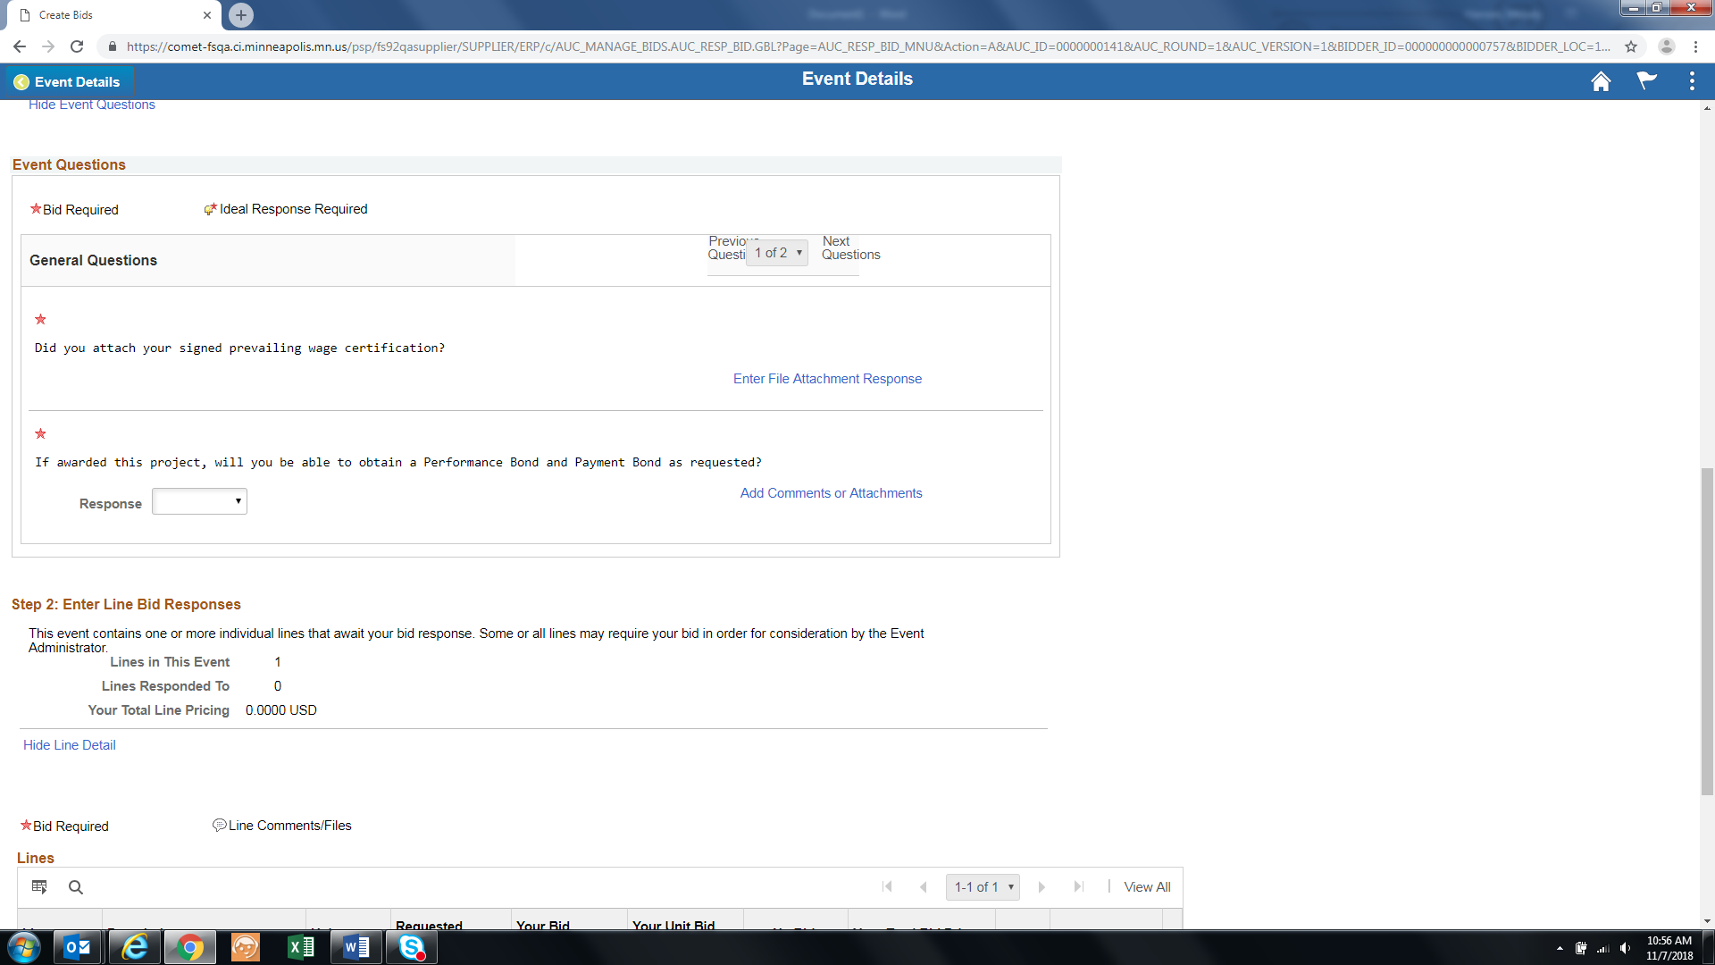

From here, you can upload a file attachment from your PC by clicking the upload button, and locating the file from your documents. Make sure to click the “OK” button when the attachment upload is complete:

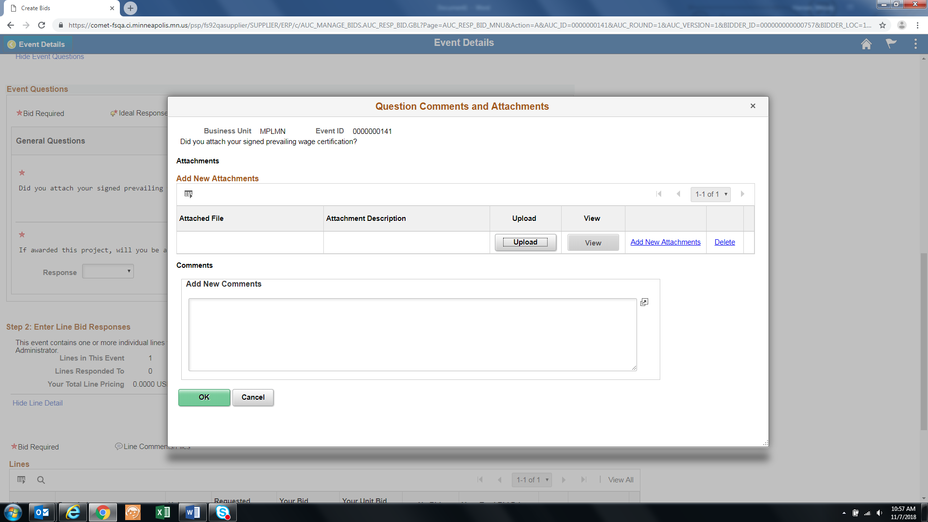

3. When all questions have been answered, you can enter your bid amount and submit your bid:

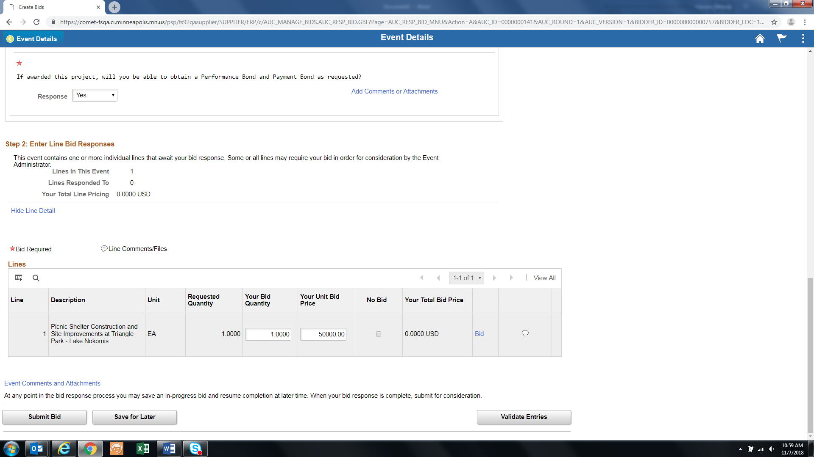

Upon submission, you will be brought to a confirmation page and will also receive a confirmation email. If the event is still posted, and you’d like to modify your bid, you can do so by clicking on the “My Event Activity” icon from the Secure Homepage.

# Bid Award

When the event submission period has ended, the City’s procurement department will review all bids and award the event to a Supplier. If you receive the award, a notice will be sent to you and you may be contacted further by the City of Minneapolis Procurement Team or Civil Rights Department to gather additional requirements.

