



City of Minneapolis Electronic Signatures Guide

December 2018

# Electronic Signatures

After the contract between your organization and the City has been drafted and sent for signatures, you will receive an email from the City via DocuSign to electronically sign the contract. The email will look like the one below, and after clicking the “Review Document” Button, you will be taken to DocuSign for the next eSignature steps:

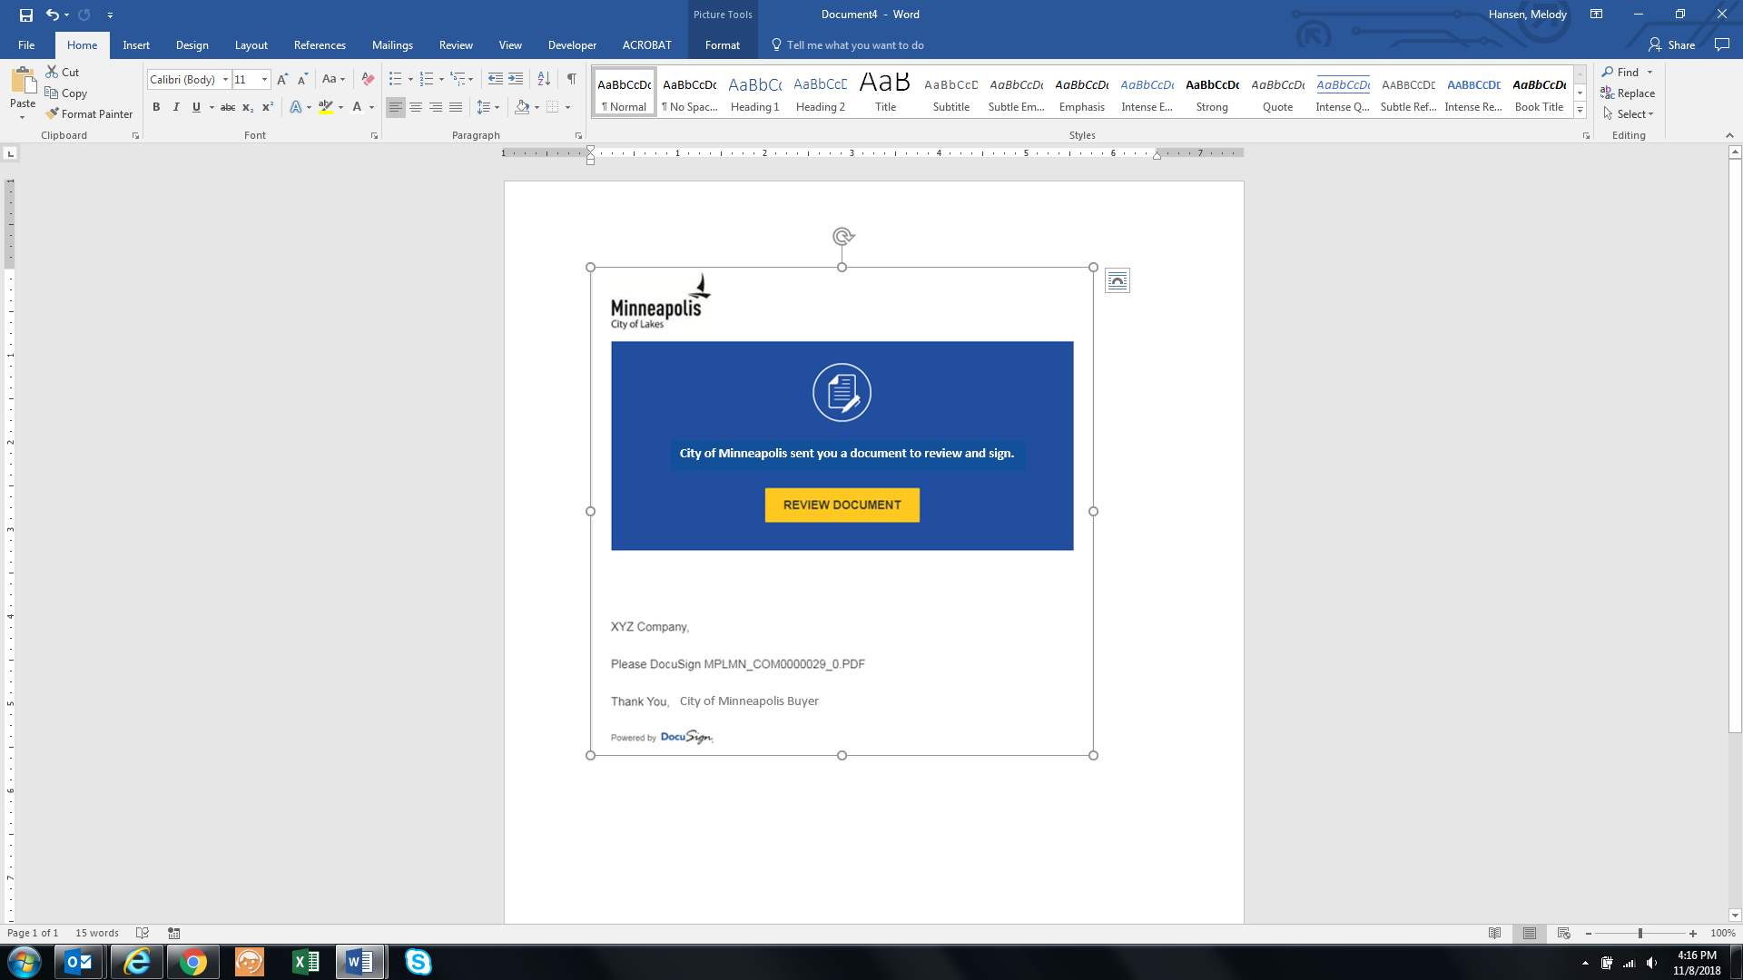

1. The document will appear in a browser window as shown above. The first time you are asked to sign a document, you will need to agree to use electronic signatures by checking the box indicated. The next time you are required to sign a document you will not need to check the box.

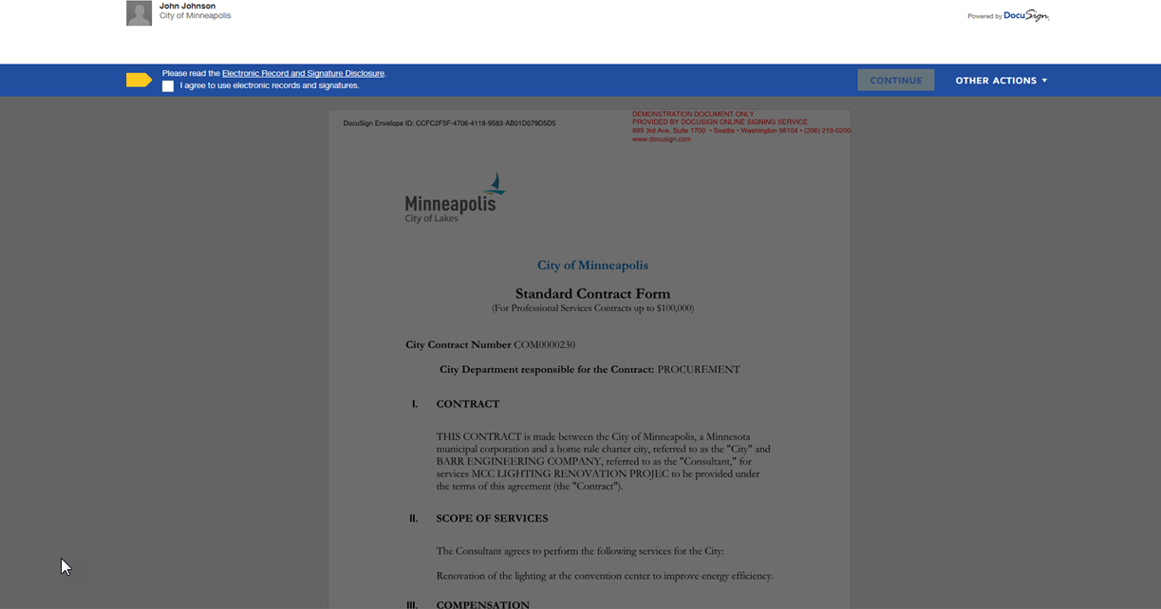

2. Once you agree, the continue box will become active. Click the OK button to remove the questions box at the top of the page and begin reviewing the contractual document. By pressing the Start button DocuSign will immediately take you to where you need to sign on the document.

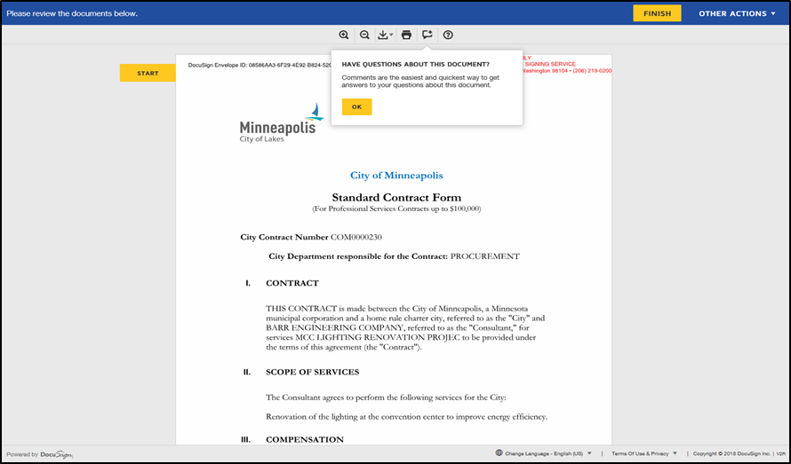

3. Once you have reviewed the document enter your title in the red box next to Title then click on the yellow Sign icon. Enter your full name as you would like it to appear along with your Initials. You can change the default signature style by clicking on the Change Style link, or you could choose to draw your name using either your mouse or smartphone/tablet by pressing the Draw tab.

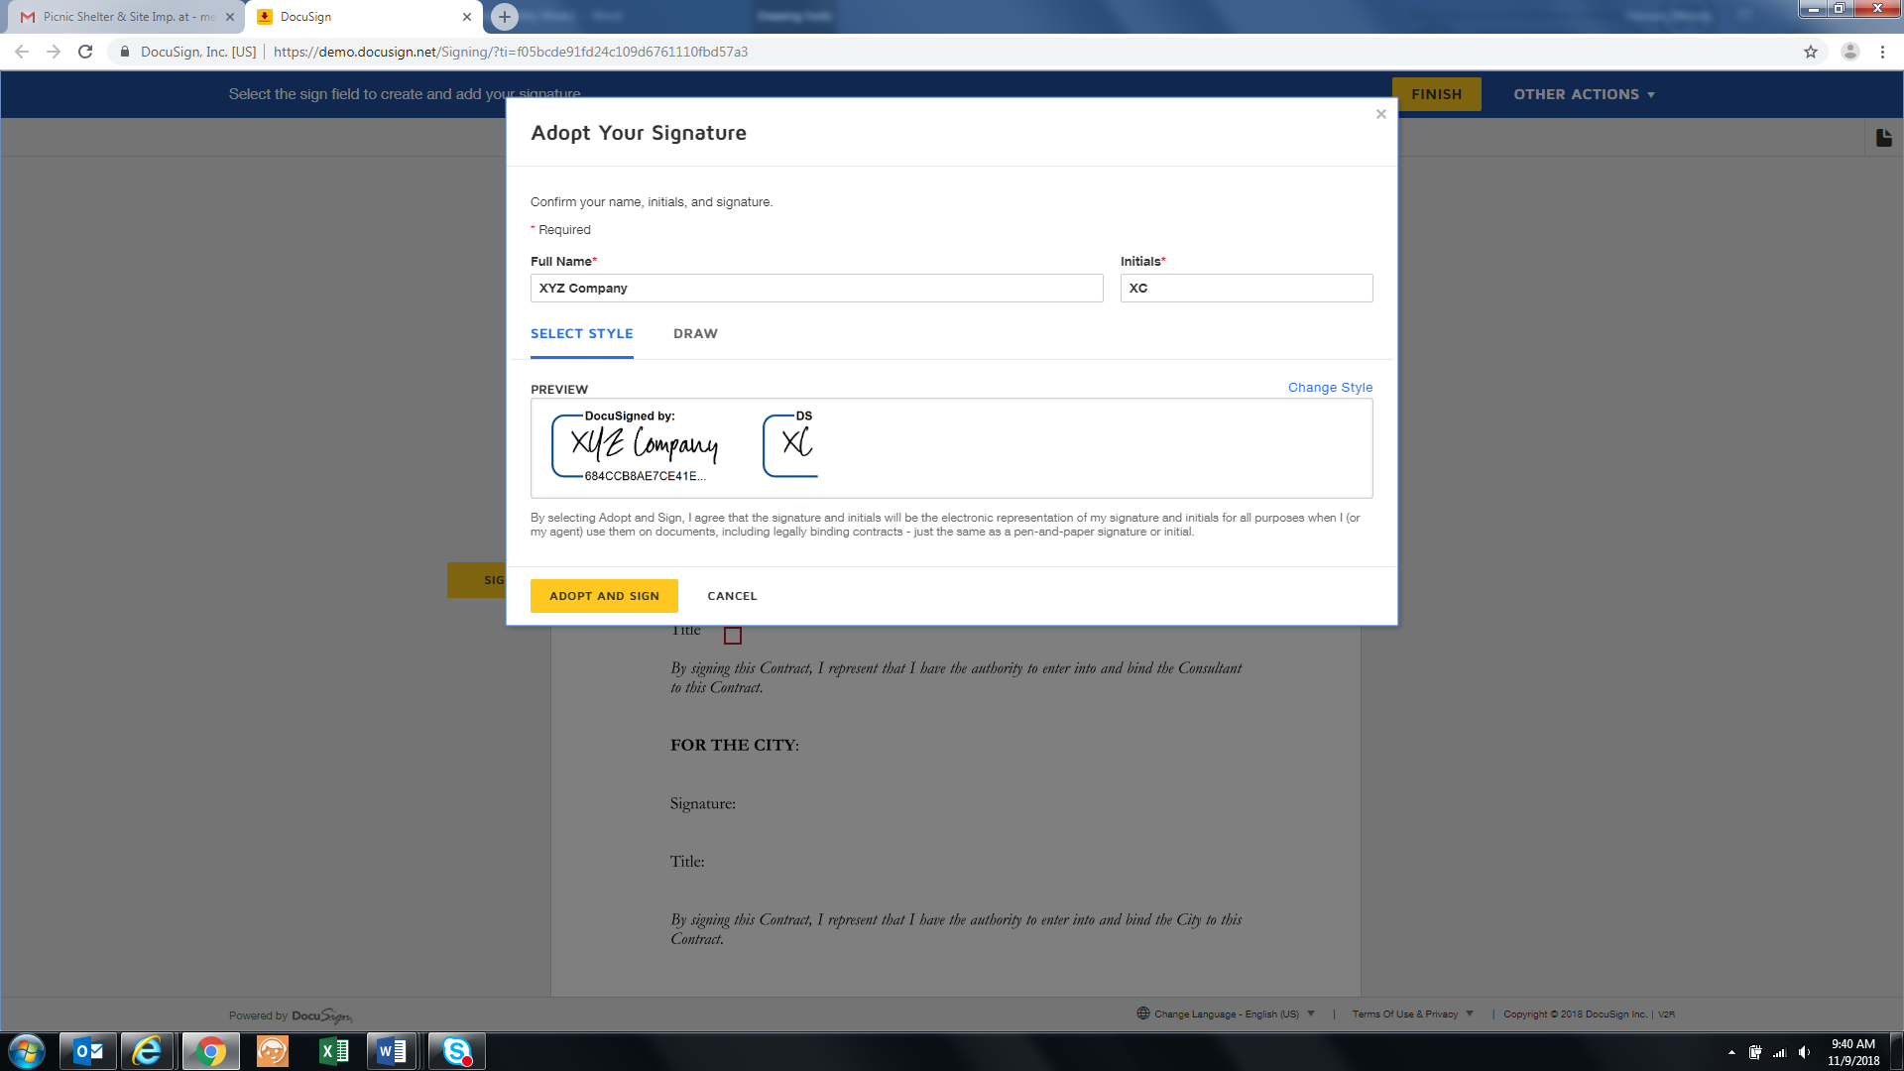

After selecting a style for your signature, click the “Adopt and Sign” button to finish signing the document. Another screen will pop up asking if you would like to create a DocuSign account, this is optional and is not required, but you may do so if you would like to.

The document will continue routing through all the assigned signatures as designated by the City of Minneapolis.

# DocuSign Assistance

If you need assistance with electronically signing a contract within DocuSign, feel free to visit DocuSign’s common signing issues webpage at: <https://support.docusign.com/en/articles/Common-signing-issues>

You can also reach out to the City of Minneapolis contract administrator who sent you the contract for review. Their email address will be provided upon sending you a contract for review and signature.

# Contact Us

If at any point you need further assistance, contact us at: Phone: 612 673-2311 or e-mail: [eProcurement@minneapolismn.gov](mailto:eProcurement@minneapolismn.gov)