



City of Minneapolis Contracting Guide

December 2018

# Bid Award

When the event submission period has ended, the City’s procurement department will review all bids and award the event to a Supplier. If you receive the award, a notice will be sent to you and you may be contacted further by the City of Minneapolis Procurement Team or Civil Rights Department to gather additional requirements.

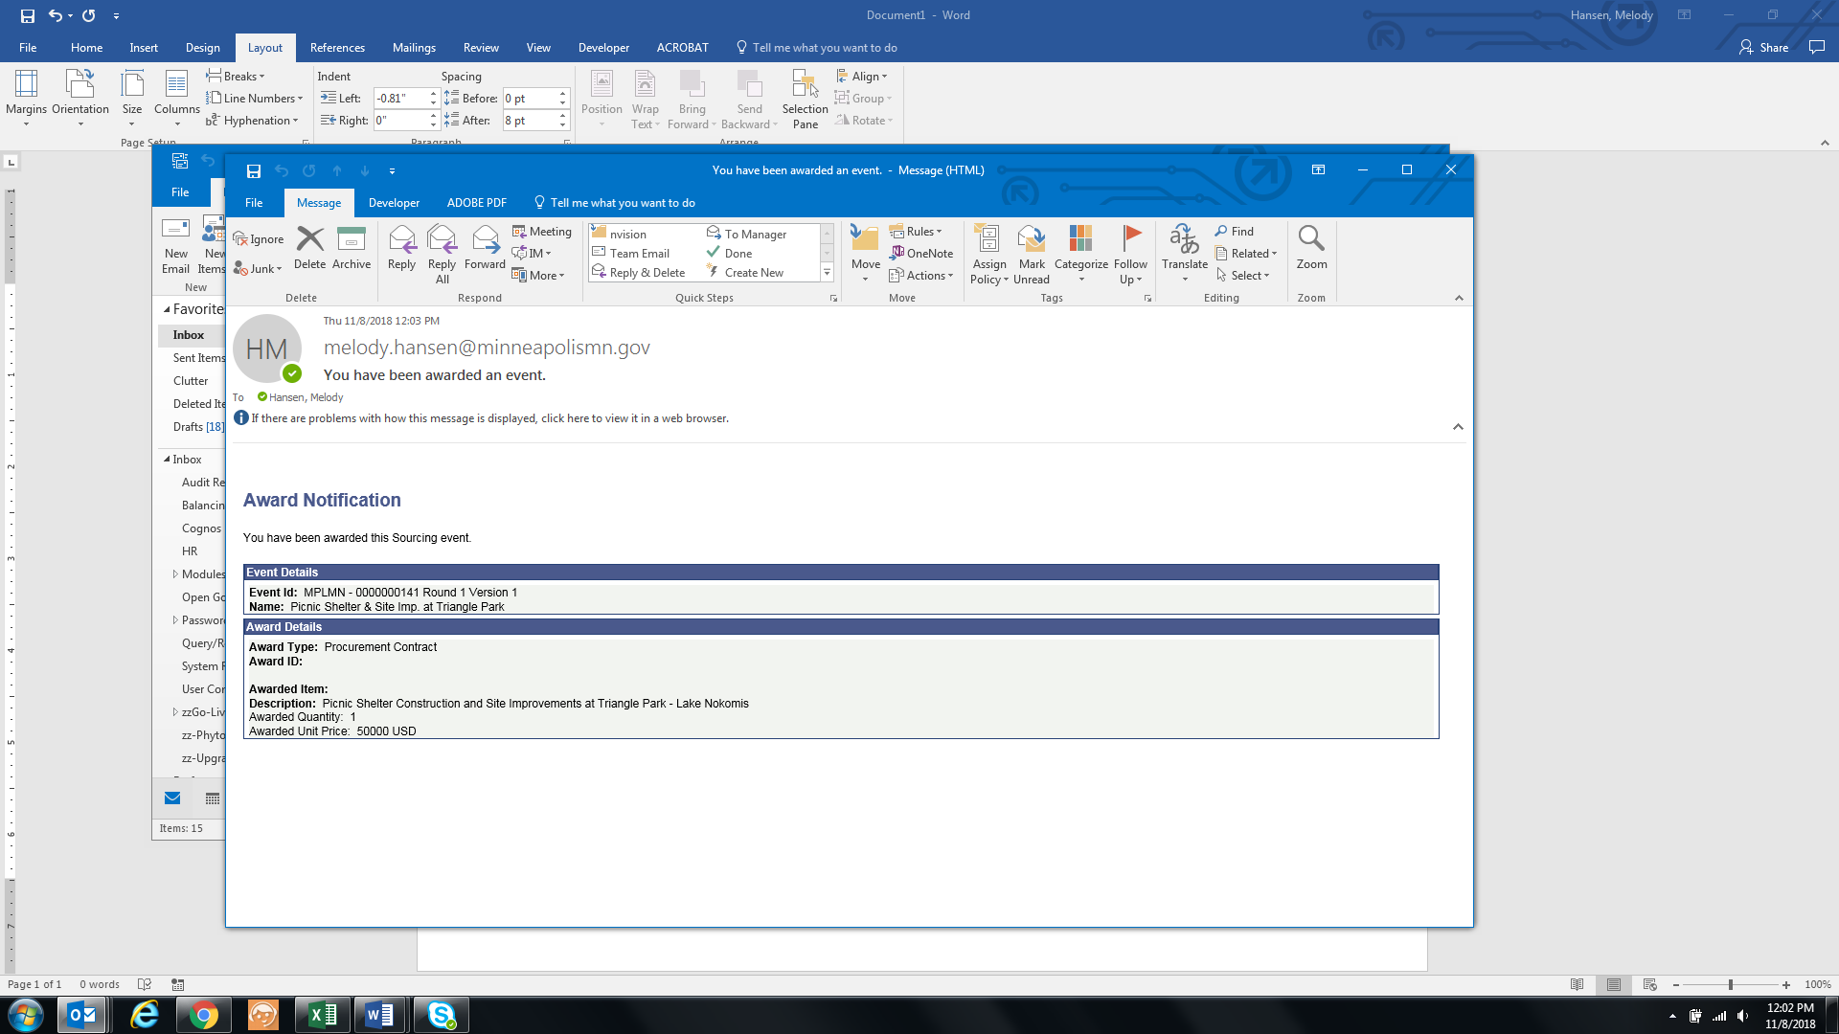

.

# Contract Collaboration

Once an event has been awarded, a contract between the Bidder’s Organization and the City of Minneapolis will be drafted. If the City needs your organization’s review on the contract verbiage, you will receive an email notification, which will direct you to view the contract details within the eSupplier portal. You will also follow this same procedure if amendments have been made to any of your organization’s contracts. Upon signing in, click the “Manage Contract Documents” icon from your secure Supplier page:

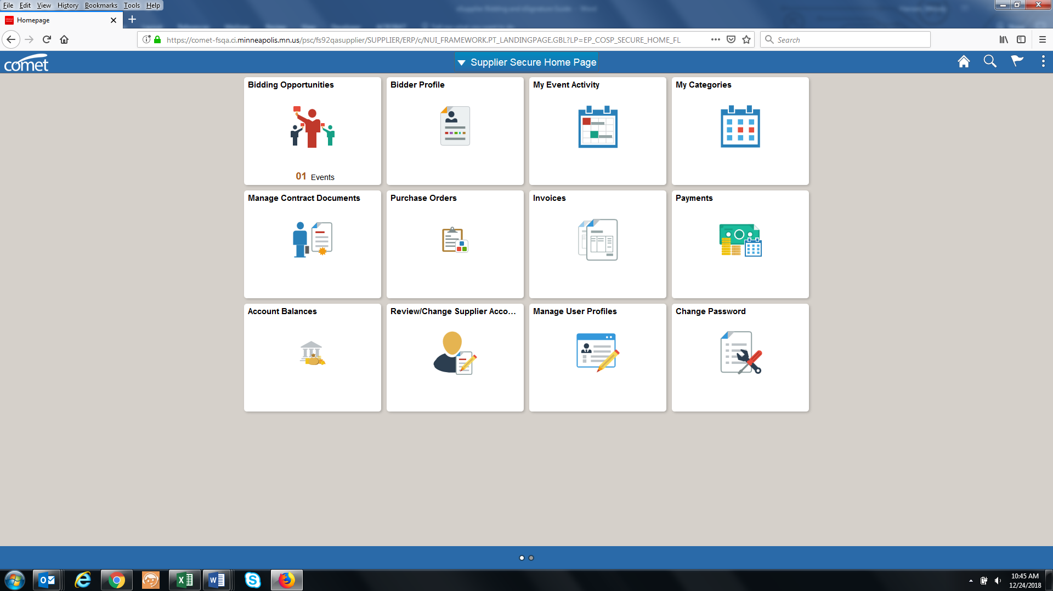

From there, click the search button to find the pending document. You can leave these fields blank, or put in search criteria, such as a date range.

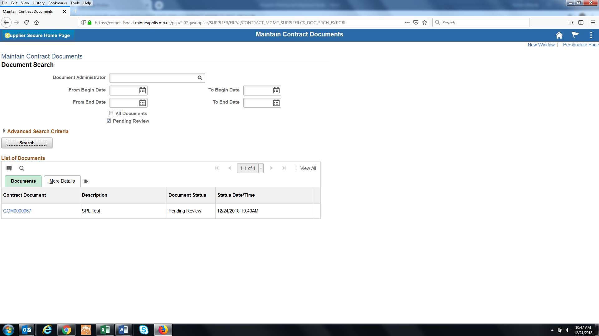

You can then click the Contract document URL from the above image, to access the contract document.

When you are directed to the maintain contract documents page, click the **view** button to review the contract agreement. If your organization would like to make edits, save the document that you just viewed, make edits as needed, and then upload the revised document via the button highlighted below:

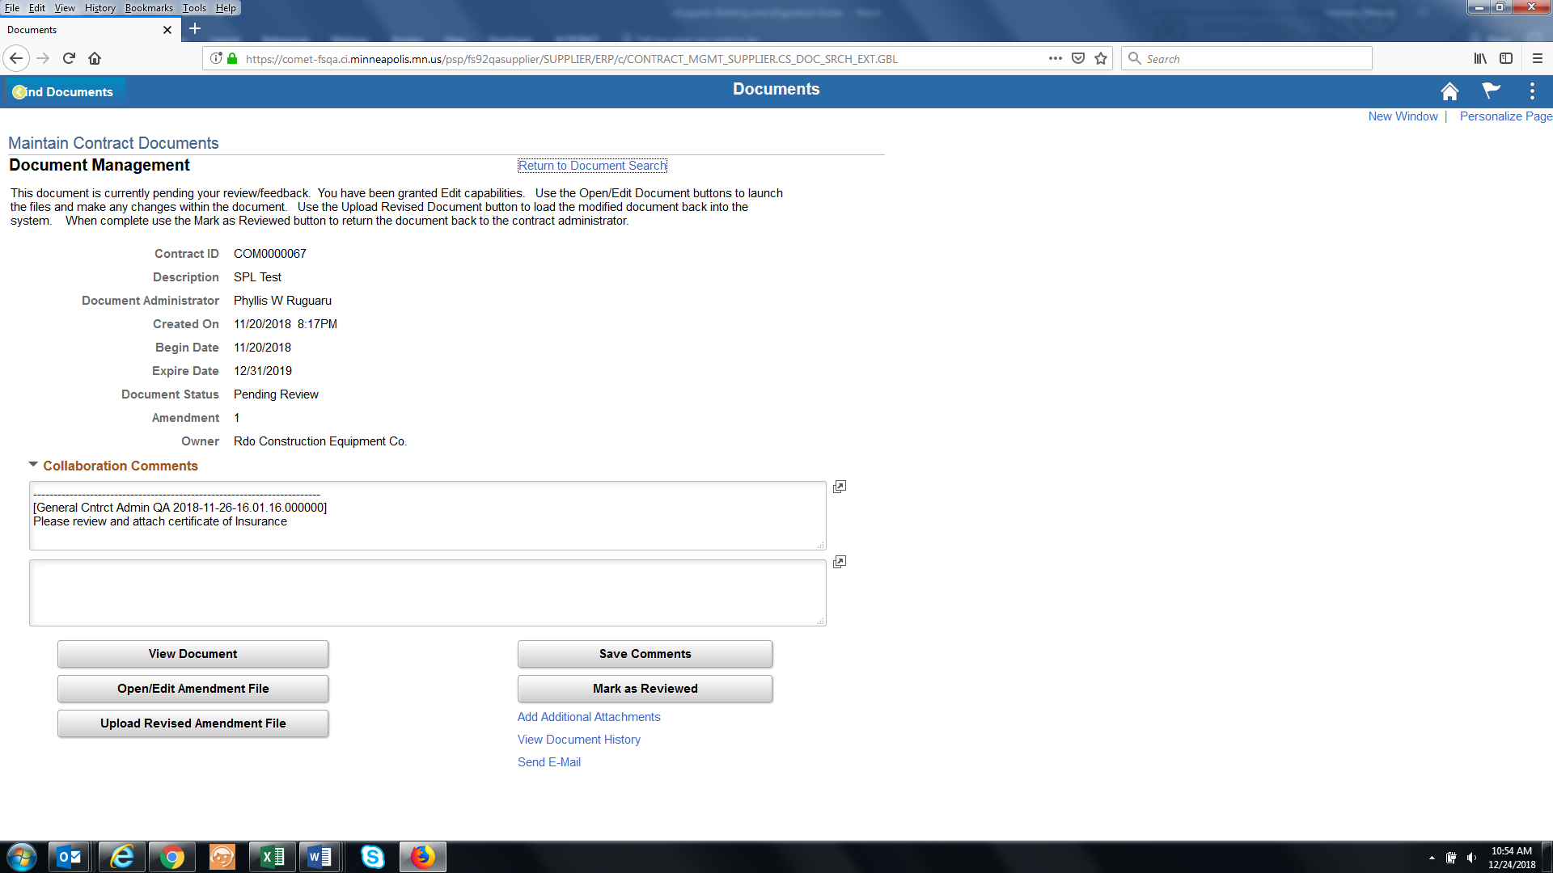

If you need to make edits, you must save the document to your personal computer and save it with the same file name that it was downloaded as. Once your edits are complete, you can then click the “upload a revised Amendment file” button.

Feel free to add additional comments, if desired. Once finished, click the “Mark as reviewed” button. This will finalize your portion of the contract review process.