# **Winter Maintenance Plan Cover Sheet**

Date:  
  
Property Manager Name:

Name of Development:

Address of Development:

Watershed:  
[Find Your Watershed: https://www.mwmo.org/learn/find-your-watershed/](Find%20Your%20Watershed:%20https://www.mwmo.org/learn/find-your-watershed/)

Winter Maintenance Management Plan Used:  
  
 Basic  
  
 Advanced

I will work to reduce salt use at this location to protect our natural resources.

Signed: _____________________

# **Basic Plan Criteria**

Required information:

* Individual responsible for the winter maintenance at this site
  + Name
  + Relation to property
  + Phone number
  + Email
* Fill out Salt Stewardship Pledge – [Minneapolis Salt Mini-Course](https://www2.minneapolismn.gov/government/programs-initiatives/environmental-programs/salt/)
  + Go through the Salt Mini-Course and fill out the pledge
  + Proof of pledge from at least one person involved in winter maintenance operations at this site
* MPCA Smart salting certificate of at least one person involved in winter maintenance operations at this site
  + Name
  + Company
  + Phone number
  + Email
  + Proof of Certificate

*[MPCA list of certified applicators](https://www.pca.state.mn.us/water/hire-certified-applicator)

*[MPCA-approved salt training calendar](https://www.pca.state.mn.us/water/smart-salting-training-calendar/2021-06)

Recommended:

Other low-salt practices (as described in Advanced Plan)

*[Parking lot manual](https://www.pca.state.mn.us/sites/default/files/p-tr1-10.pdf) (includes recommended practices for lowering salt use).

# **Basic Plan Cover Sheet Example**

**Property Manager Name:** Julie Jones

**Name of Development:** Park N Ride West

**Address of Development:** 123 main street, Wayzata MN 55391

**Date:** 7/3/21

**Watershed:** Minnehaha Creek

**Winter Maintenance Management Plan Used:** Basic

I will work to reduce salt use at this location to protect our natural resources.

**Signed:** Julie Jones

# **Basic Plan Criteria Example**

 Individual responsible for the winter maintenance at this site

* + **Name:** Joe Smith
  + **Relation to property:** Contractor
  + **Phone number:** 688-876-3445
  + **Email:** [Smith@gmail.com](mailto:Smith@gmail.com)



Fill out Salt Stewardship Pledge – [Minneapolis Salt Mini-Course](https://www2.minneapolismn.gov/government/programs-initiatives/environmental-programs/salt/)

* + Go through the Salt Mini-Course and fill out the pledge
  + Proof of pledge from at least one person involved in winter maintenance operations at this site

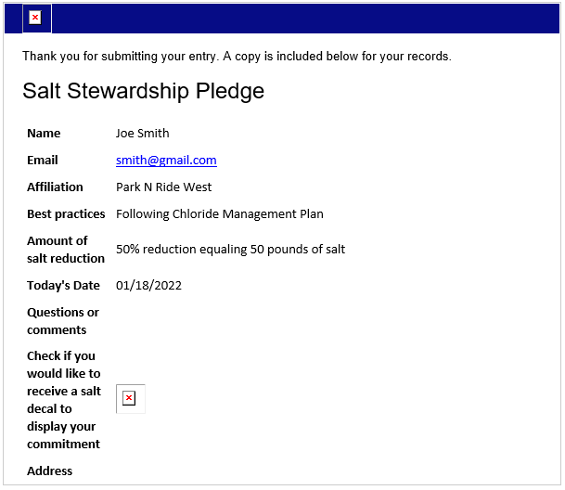

Smart salting certificate of at least one person involved in winter maintenance operations at this site**:**

* + **Name:** Sarah Kinney
  + **Company:** FCI
  + **Phone number:** 123-321-1234
  + **Email:** Sarah@Fortinconsulting.com
  + **Proof of Certificate**: 4/5/21

